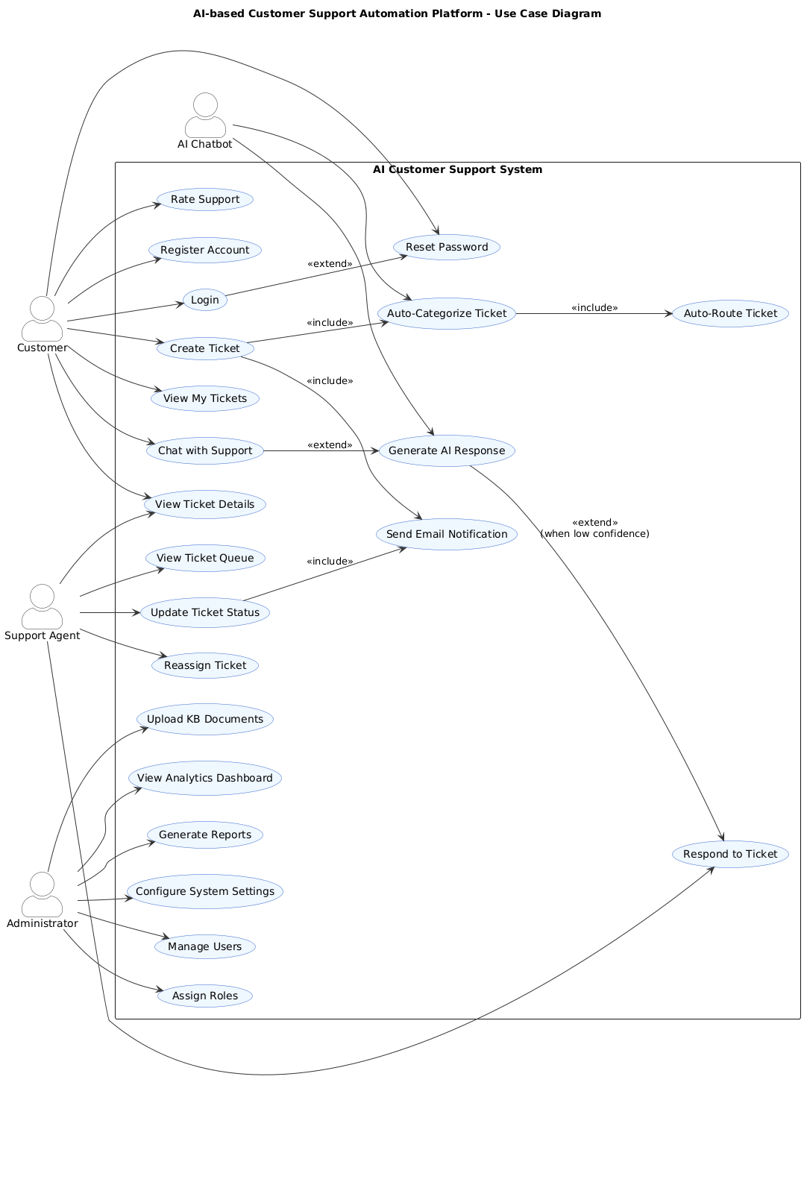
USE CASE DIAGRAMs
Use Cases Identification

Customer Use Cases
Register Account - Create new user account with email verification
Login to System - Authenticate with email and password
Create Ticket - Submit new support ticket with title and description
View Tickets - See list of own tickets with status
Chat with Support - Real-time messaging with agent or AI bot
Search Tickets - Find specific tickets by ID, title, or keywords
View Ticket Details - See complete ticket information and chat history
Rate Support - Provide satisfaction rating after ticket resolution
Reset Password - Request password reset via email
Update Profile - Modify personal information

Support Agent Use Cases
View Ticket Queue - See assigned and pending tickets
Accept Ticket - Take ownership of a ticket
Respond to Ticket - Reply to customer queries
Update Ticket Status - Change status (Open/In-Progress/Resolved/Closed)
Reassign Ticket - Transfer ticket to another agent
View Analytics - See personal performance metrics
Search Knowledge Base - Access company documents for information

Admin Use Cases
Manage Users - Create, edit, disable user accounts
Assign Roles - Grant Customer/Agent/Admin privileges
Upload Documents - Add files to knowledge base
Configure Settings - Set system parameters (auto-close time, escalation rules)
View System Dashboard - Monitor overall system performance
Generate Reports - Create daily/weekly/monthly analytics reports
Manage Categories - Add/edit ticket categories
View Audit Logs - Track all user actions

AI Bot Use Cases
Categorize Ticket - Auto-assign category based on description
Suggest Response - Provide AI-generated answer from knowledge base
Auto-Respond - Send response if confidence score > 75%
Escalate to Agent - Forward to human if confidence low

System Use Cases (Backend)
Send Email Notification - Alert users of status changes
Auto-Close Ticket - Close resolved tickets after 7 days
Generate Ticket ID - Create unique identifier for new tickets

Actors Identification

Primary Actors (Direct Users)
Customer - End user who needs support
Support Agent - Employee who handles customer queries
Administrator - System manager with full access
Secondary Actors (Systems/Services)
AI Chatbot - Automated response system using Gemini API
Email System - Gmail SMTP service for notifications
Knowledge Base - Document repository with ChromaDB

